**WOMEN’S STUDIES CENTRE**

**SRI KRISHNADEVARAYA UNIVERSITY, ANANTHAPURAMU**

**Awareness Programme**

**The Awareness Programme on National Nutrition Week 2025 Poshan Maah - "Swasth Nari Sashakth Pariwar."** program was successfully organized on 26/9/2025 at 11:00AM at Phule Bhavan with the objective (to improve nutrition health awareness and overall well being among children and women by Women Studies Centre, Sri krishnadevaraya University, Anantapur.

children and women by Women Studies Centre, Sri krishnadevaraya University, Anantapur.

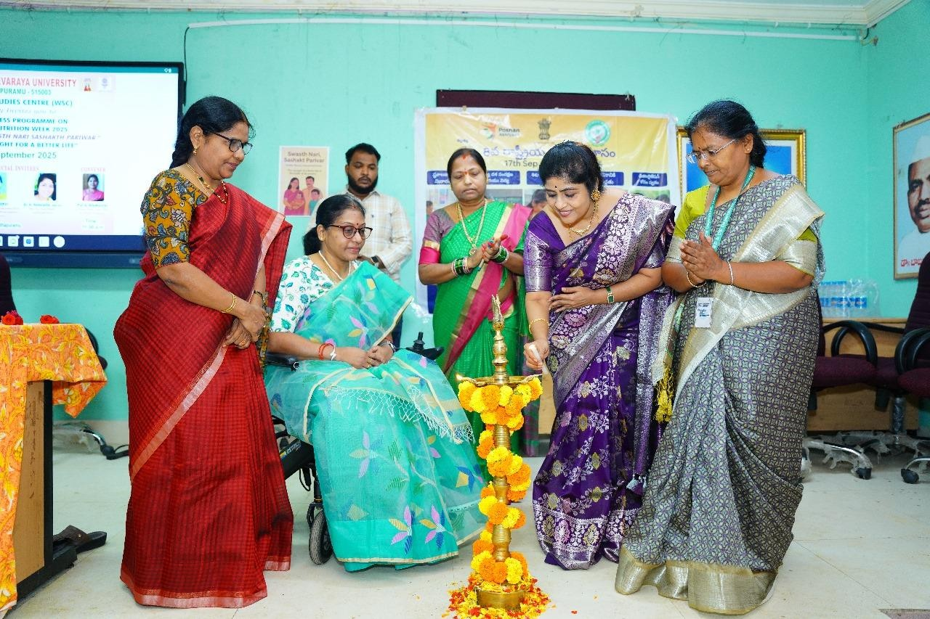

The lighting of the ceremonial lamp all dignitaries

.

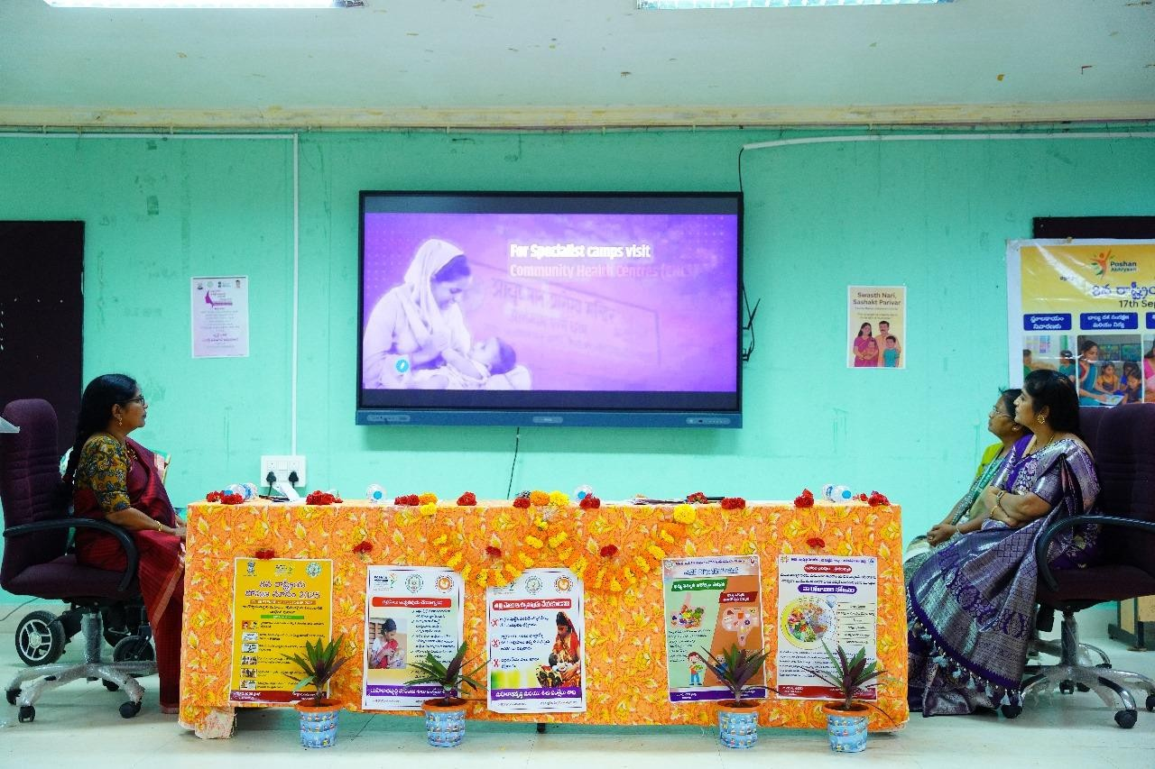

The second AV showcased the efforts of **Hon’ble Chief Minister Shri Nara Chandra Babu Naidu Garu**, emphasizing state-level nutrition and welfare schemes dedicated to women and children.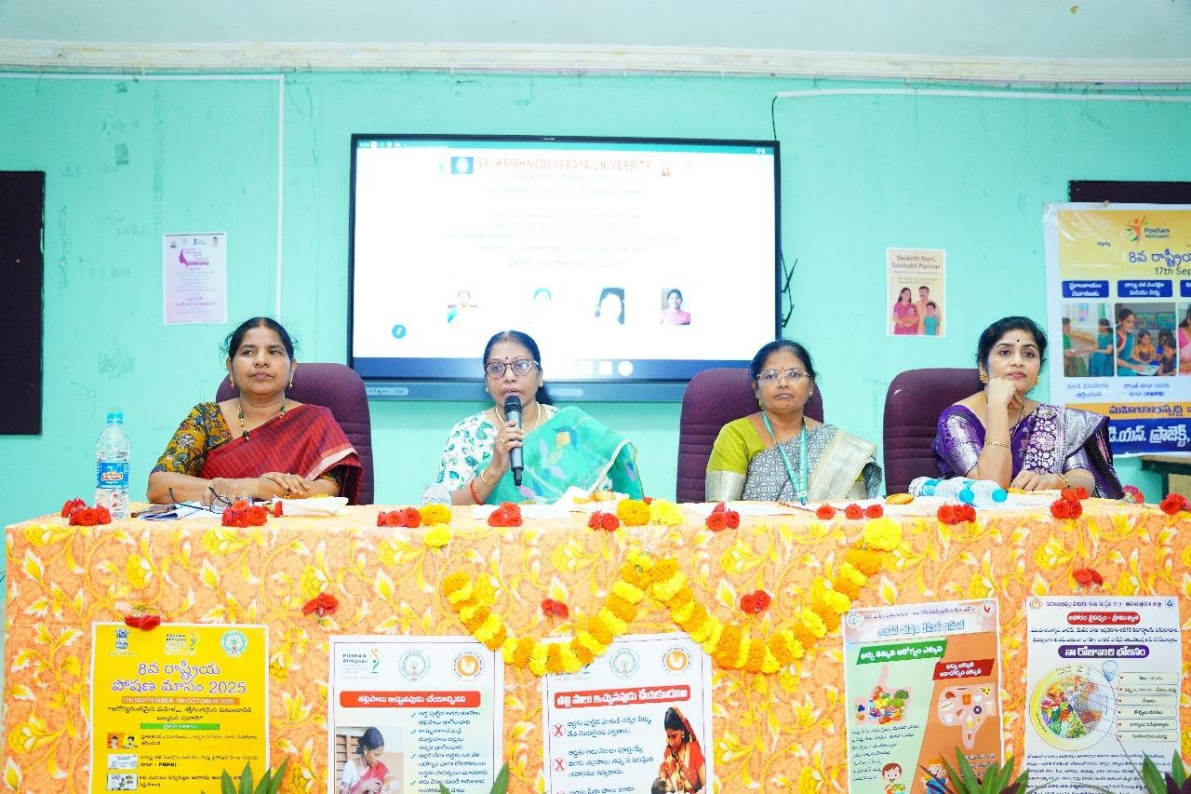 The Hon’ble Vice-Chancellor (i/c) Madam Prof. B. Anitha delivered an inspiring and

enlightening speech.

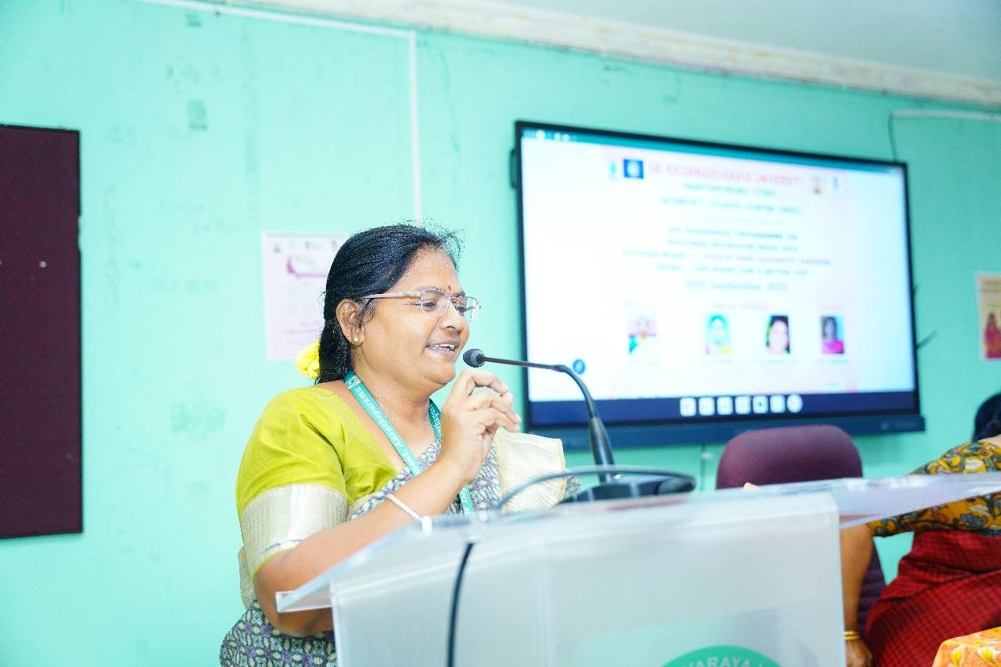

**Dr B.N. Sridevi, District Mission Coordinator, Women Development and Child Welfare Department** delivered an enlightening session on the theme *“Nutrition in Daily Life and the Proportion of Healthy Food for Women.”*

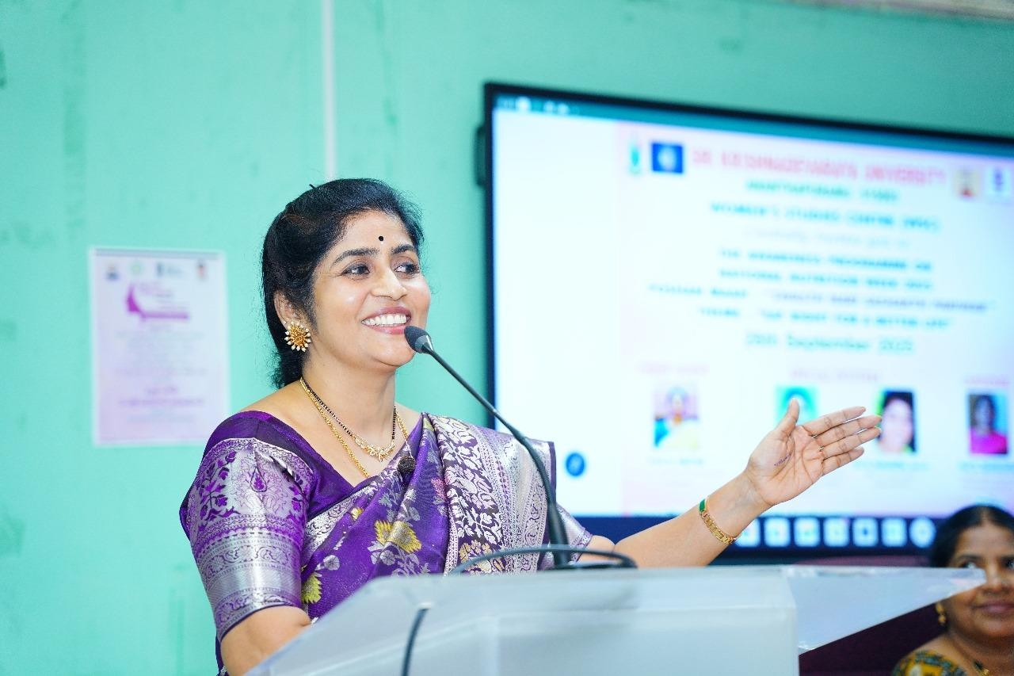

**Dr. G. Hemalatha, MBBS DCH RMO-Govt. General Hospital, Ananthapuramu District** delivered a highly engaging and insightful talk on the topic *“Practical Experiences in Hospitals and the Importance of Women’s Health in Society.”*

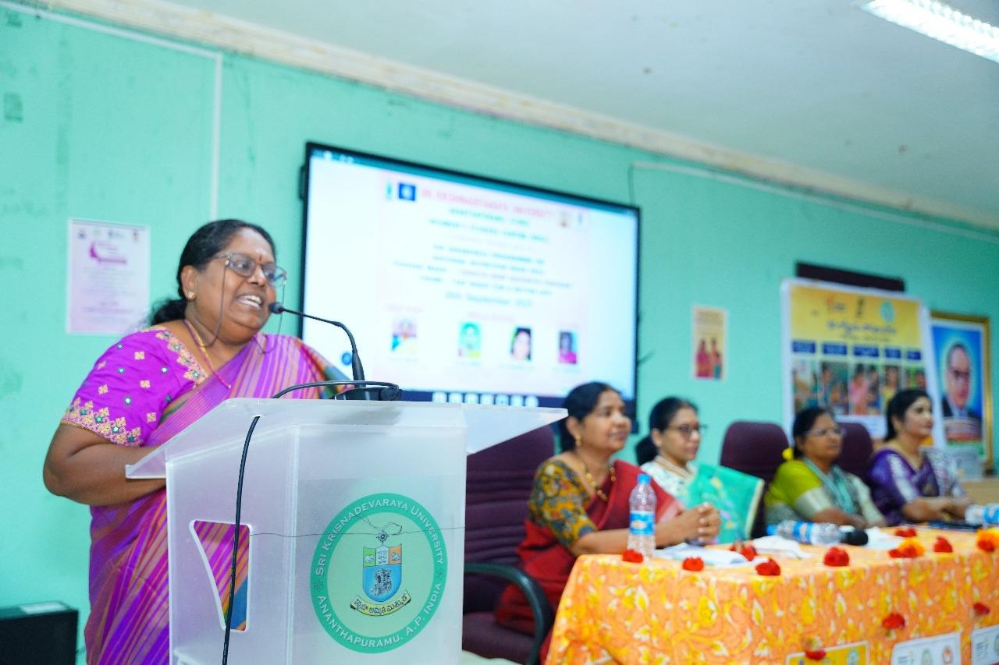

After all the guest lectures, **Smt. Uma Devi, a counselor**, addressed the gathering with a thought-provoking talk. She highlighted the growing issue of **increasing divorces in society.**

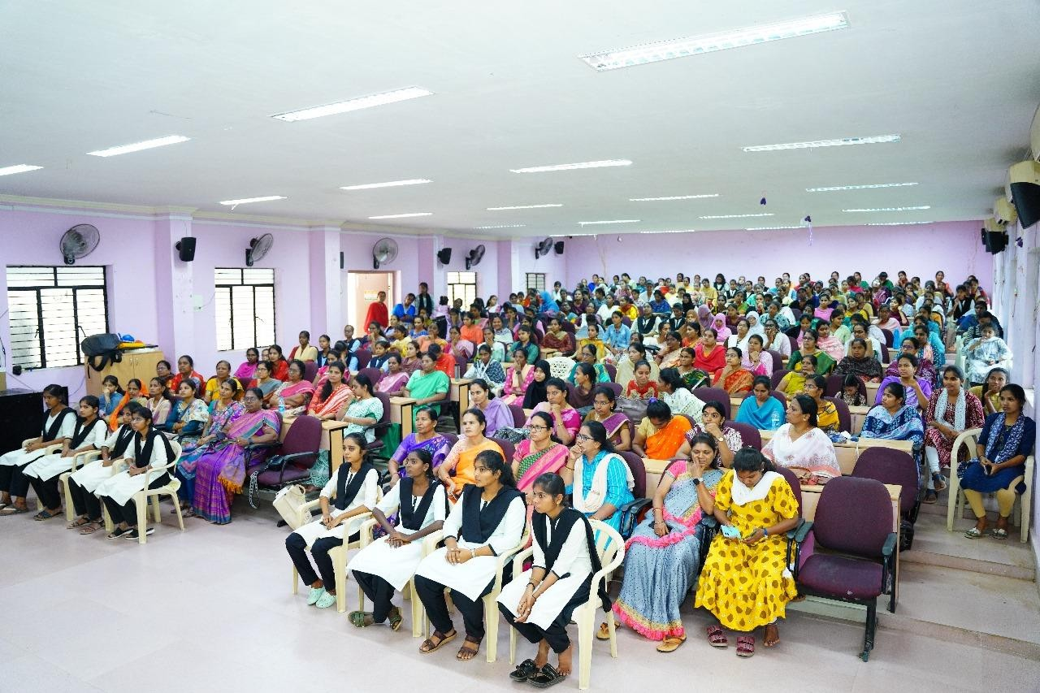

**Felicitation of Guests**

As a mark of respect and gratitude, the dignitaries and speakers were **felicitated with mementos and shawls** by the organizers.

